Prescribing Tip For Information
Pharmacy First service starts 31.01.24 to treat SEVEN common ailments
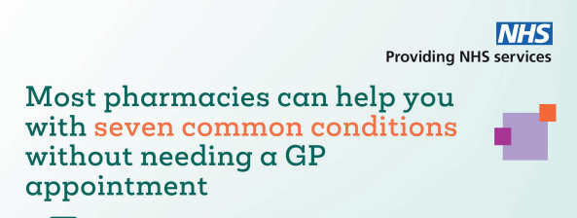
Community pharmacy is to step further into its’ clinical future, working more closely with general practices as part of the integrated NHS primary care team. This will enable the management of common infections by community pharmacies through offering self-care, safety-netting advice, and supplying certain over the counter and prescription only medicines via clinical protocol and patient group directions.
- Female urinary tract infections (16-64yr)
- Earache (1 -17yr)
- Sore throat (adults & children >5yr))
- Sinusitis (adults & children >12yr))
- Impetigo (adults & children>1yr)
- Shingles (adults >18yr)
- Insect bites (adults & children>1yr)

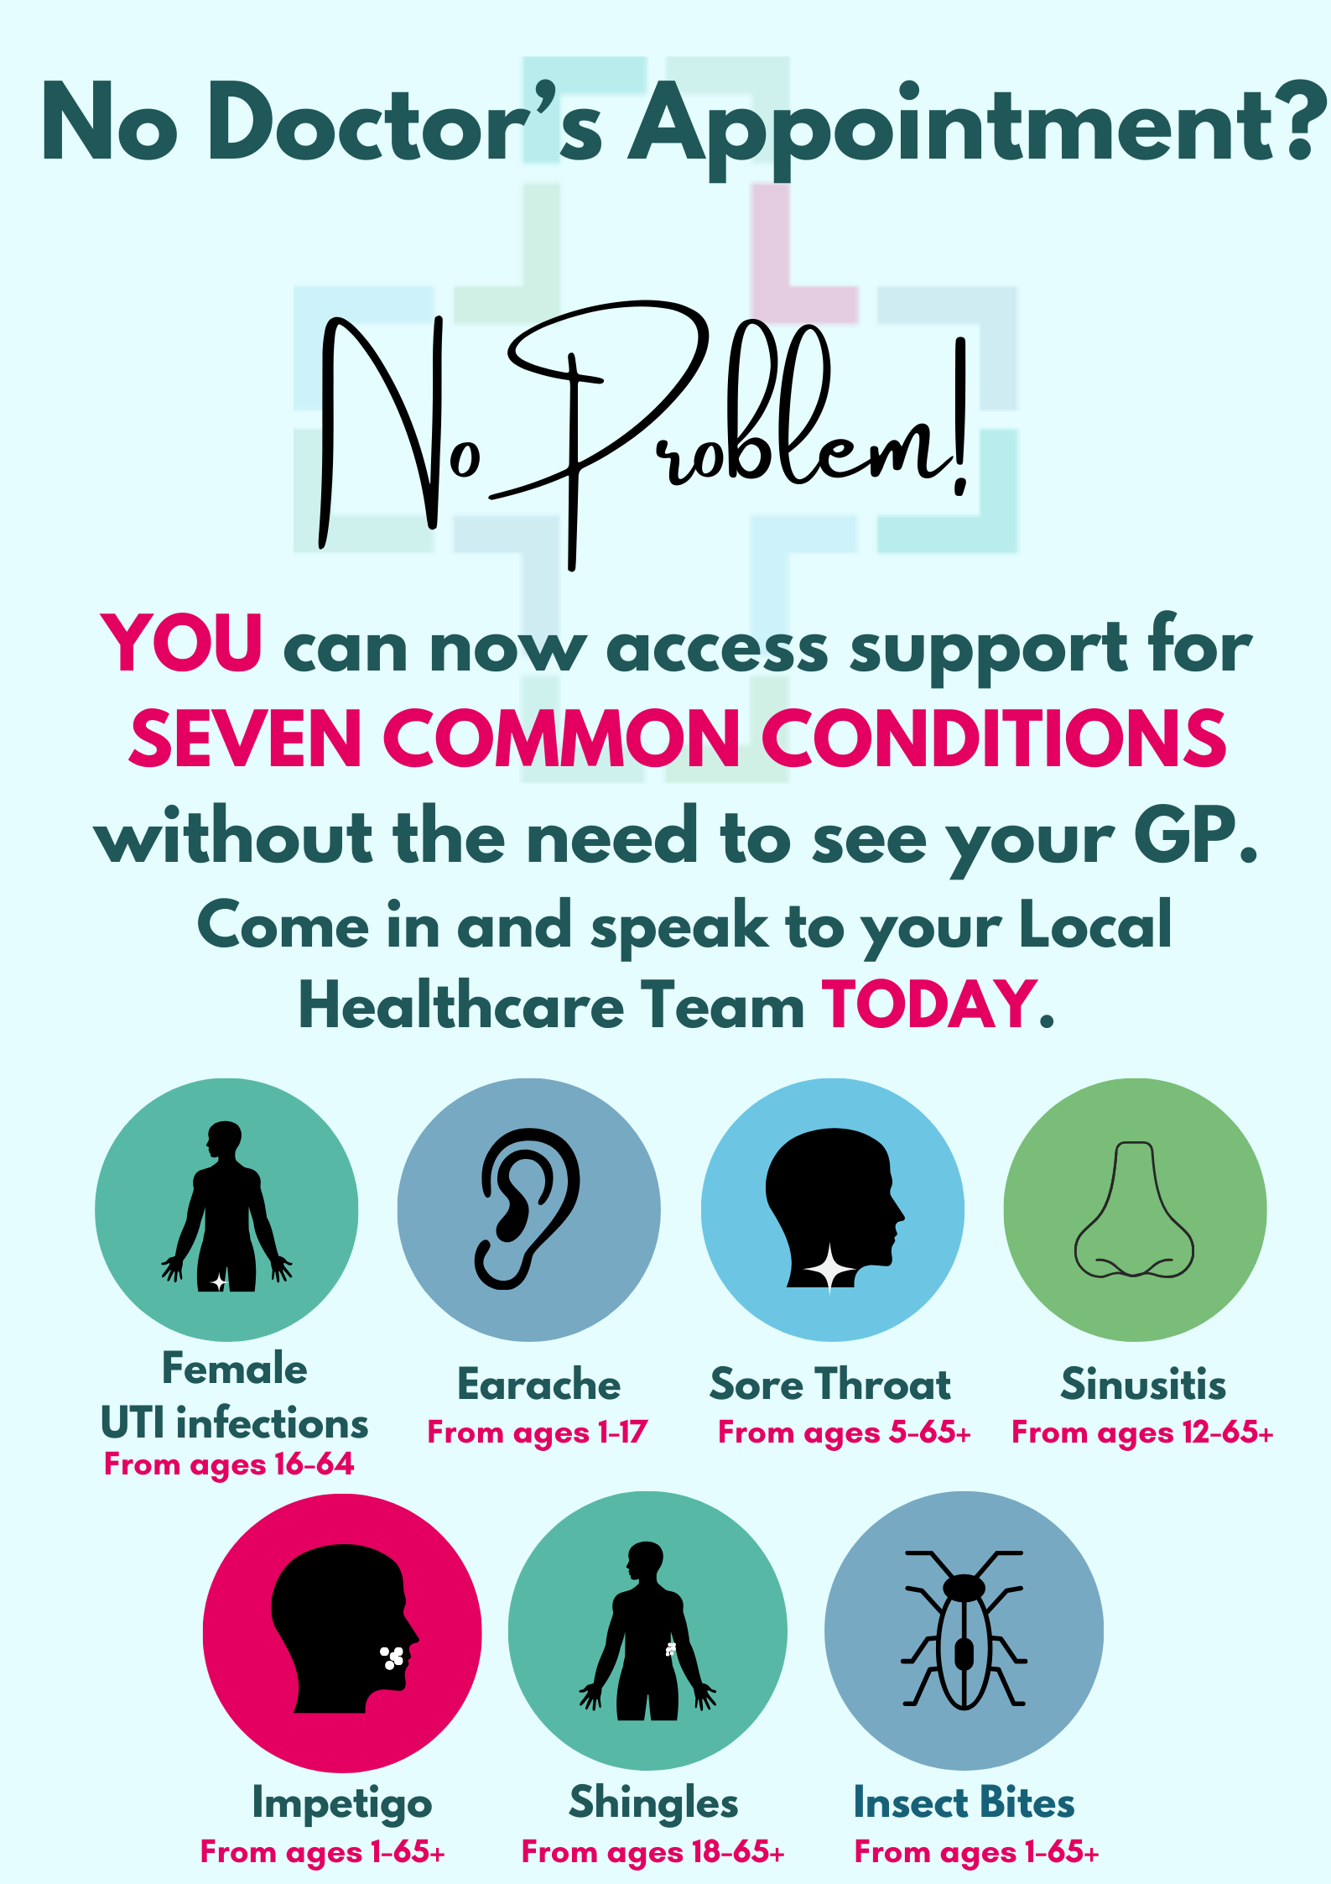
The aim is to further utilise the clinical skills of community pharmacy teams to complete episodes of care for patients displacing activity from general practice and urgent care settings.
Before beginning to deliver the service, pharmacy contractors must ensure that pharmacists who are providing the service, including locums, are competent to do so, and are familiar with the 7 clinical pathways, clinical protocol, and patient group directions. These provide robust pathways for pharmacists to follow, and ensure services and medicines are provided in a safe and consistent manner, which the public and NHS can trust.
Pharmacy teams will have access to a new Pharmacy First IT module which will allow them to make the necessary clinical records for the consultations provided as part of the service and send post-event messages to the patient’s general practice, via NHSmail, as is currently the case for the Community Pharmacist Consultation Service (CPCS.)
Onward referral for an urgent appointment may occur if the pharmacist needs additional advice or needs to escalate the patient to a higher acuity care location.
Pharmacy First is a shared responsibility of primary care teams, with support needed for community pharmacy colleagues from general practice, primary care networks and from integrated care boards.

